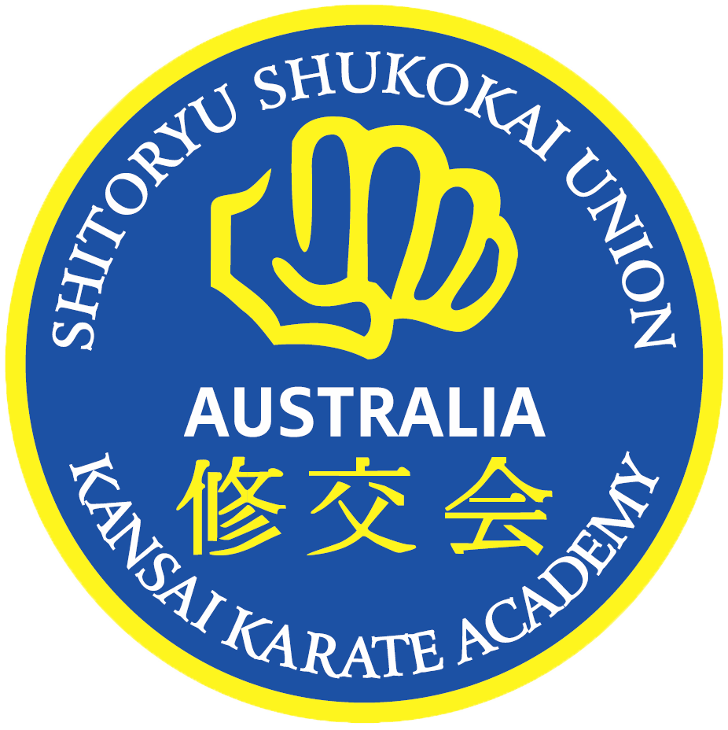

 

Nunchuku Party

What you get:

* 1 ½ hours of fun hosted by qualified Instructors with Blue Cards
* Nunchuku Drills and how to use them
* A karate uniform for the Birthday Child
* A Samurai Sword to cut the Birthday Cake
* Safe and secure premises with plenty of parking
* Safety foam Nunchuku provided (also available for sale)
* Optional Extra – Awesome Jumping Castle for an additional cost
* Catering can be arranged for an additional cost



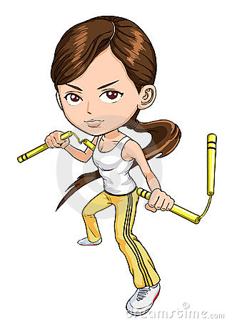

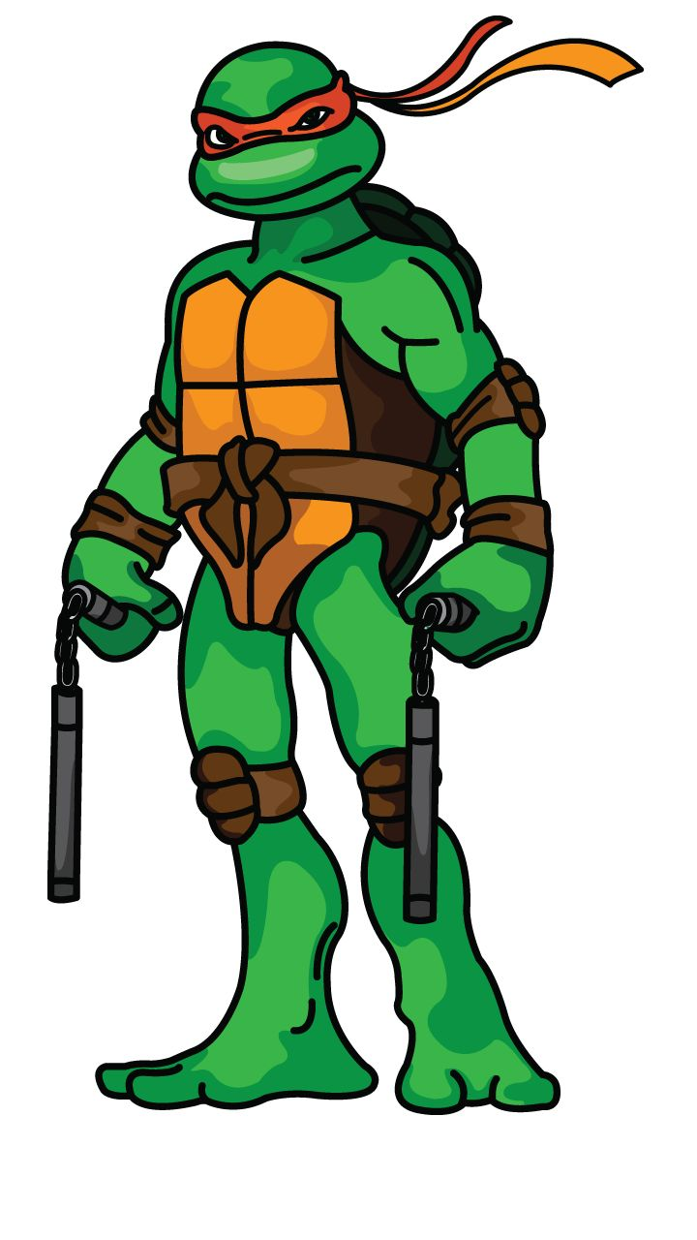

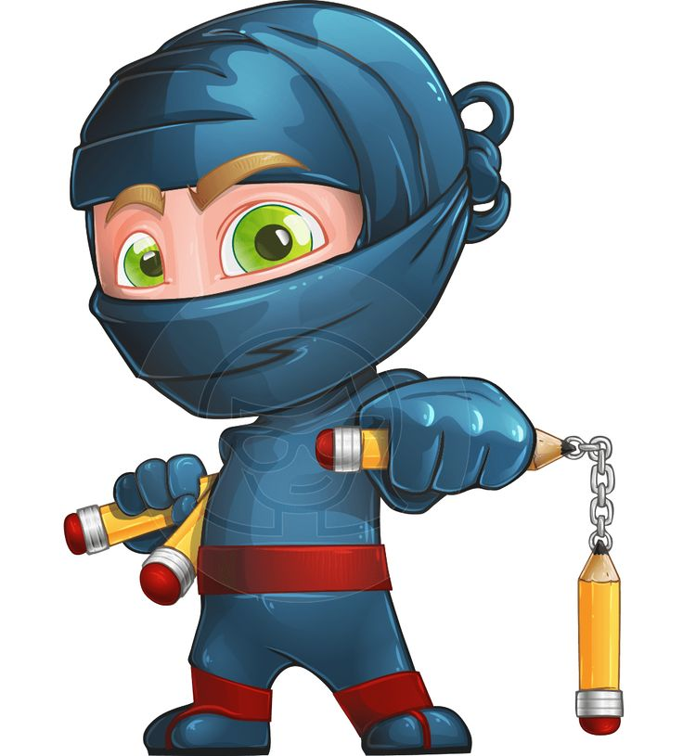

***Parties are held at our full time premises – Unit 5, 71 Jijaws Street, Sumner Park***.

Bookings are made subject to availability. Please fill out application form attached, and catering form if desired and return, with deposit, to secure your booking. Balance is payable one week before party date.

Chief Instructor and National Coach: Shihan Stephen Kelly, Kyoshi 7th Dan

Address: Unit 5, 71 Jijaws Street, Sumner Park Q 4074

Postal Address: P O Box 4005, Springfield Central Q 4300

Phone: 3279 0655 Mobile: 0417 709 729

[admin@kanasaikarate.com.au](mailto:admin@kanasaikarate.com.au) [www.kansaikarate.com.au](http://www.kansaikarate.com.au)

facebook.com/kansaikarateacademy